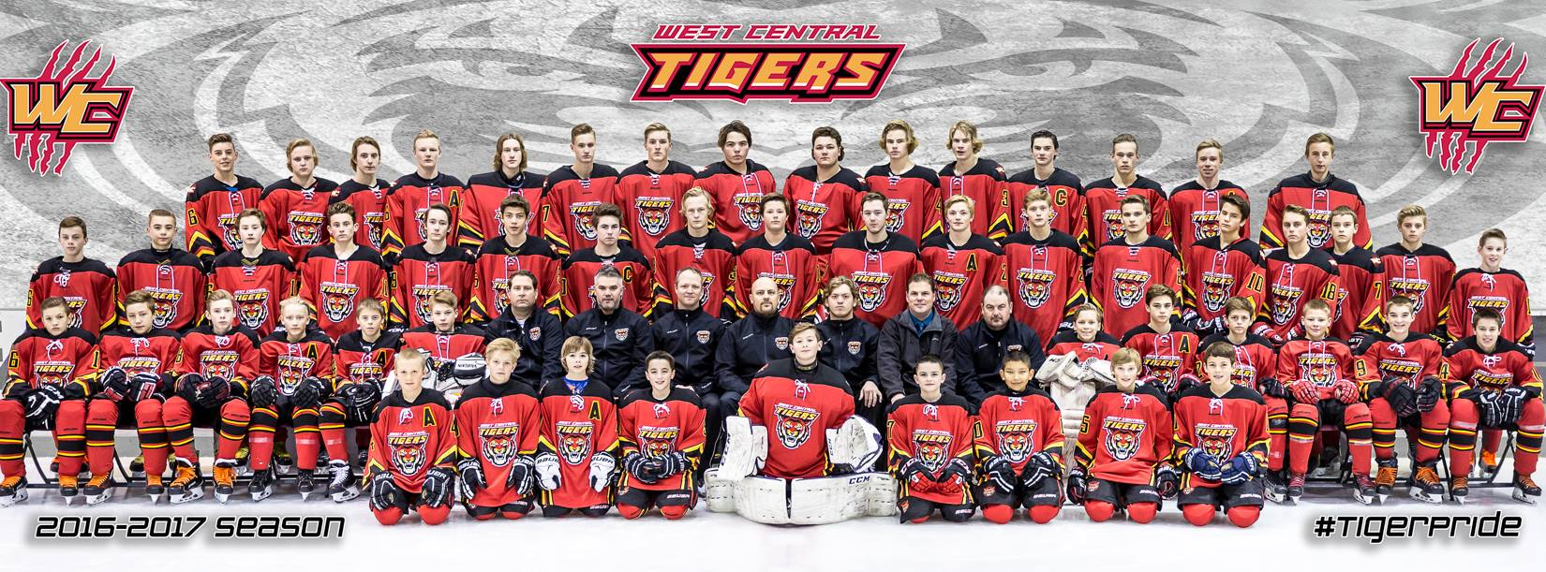
WEST CENTRAL TIGERS

SPONSORSHIP AND INFORMATION
PACKAGE

Our Vision:
“To provide regional aa peewee, bantam and midget hockey players with age specific player development that prepares them for advancing their hockey careers.”

TABLE OF CONTENTS

About Us Pg. 3
Relationships and Regulation Pg. 4
Player Development Pg. 4
Coaching Pg. 5
Season and League Play Pg. 5.
Team Selection Pg. 6
Operation Pg. 7
Sponsorship Opportunities Pg. 8
Summary and Contact Information Pg. 10

ABOUT US

The West Central Tigers organization is a fourth year AA Hockey HUB whose mission is to provide players with access to skilled coaching and programming that focuses on Peewee, Bantam and Midget hockey development in a challenging and fun environment.

Everyone in the organization will adhere to the notion of player development first - winning second.

Our vision to provide regional aa peewee, bantam and midget hockey players with age specific player development that prepares them for advancing their hockey careers.

Goals of the program:

- Provide access to highly-trained and skilled coaching;
- Make the hockey experience a fun and positive learning experience;
- Enhance the hockey skills.
- Provide an opportunity to play in a league that challenge players at their competitive skill and maturity level;
- Teach players skills that go beyond hockey and ensure lifelong learning and success.

Each coach, player and parent who participates in the Tigers program is expected to adhere to our organization’s goals and standards:
Coaches, Parents and Players will be expected to work together to ensure a successful year.
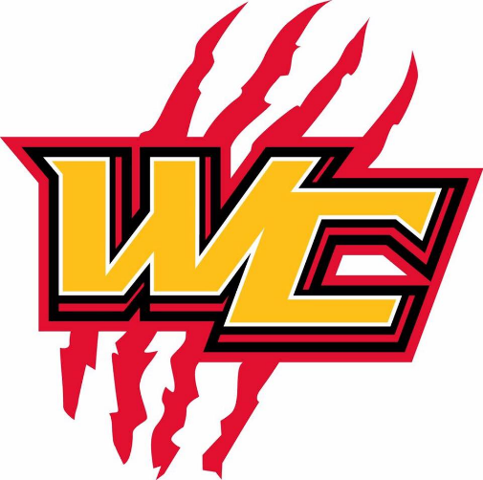
Players are expected to represent themselves and the Tigers Organization with a high level of respect for themselves, team mates, opponents, coaches, officials and
parents.
Players will
demonstrate the
willingness to make
sacrifices for the team.
Players will train in a
culture of excellence and demonstrate their commitment to achieving their full potential on and off the ice.

RELATIONSHIPS AND REGULATION

The Tigers program is proud to be part of Rural Central Alberta’s historical hockey organizations. The Tigers are the result of a collaboration between the Sylvan Lake, Rocky Mountain House, Bentely, Rimbey, Caroline, Eckville, Spruce View minor hockey associations.

Eligible players within the Sylvan Lake “AA” Hockey Model Recruitment Area will be allowed to tryout if they reside within the Sylvan Lake AA Model Draw Zone. The Sylvan Lake AA Model Draw Zone makes up and will be referred to as the West Central Tigers AA HUB.

Home games and practices will be held within the West Central Tigers AA HUB Draw Zone.

PLAYER DEVELOPMENT
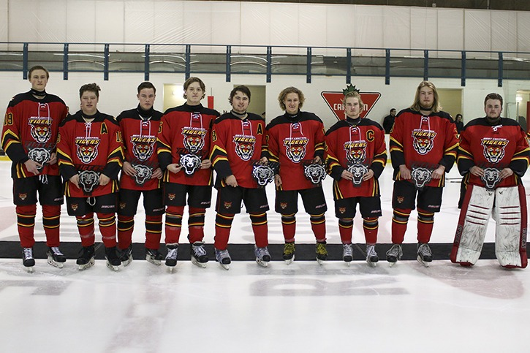
Our player development model revolves around these key areas, accentuated by the focussed goals, maturity and skill level of our athletes:
1. Skating - Players will be taught how to understand their edges, how to control their core, how to generate and maintain speed, while building stamina and then integrating these skills with a puck.
2. Individual Skill - Players will be given the opportunity to work on their shooting, passing and stick handling at game speed. There will be an emphasis on developing creativity around these skills.
3. Team Play - Players will work on offensive and defensive tactics, systems and strategies. They will learn these skills in game-like drills and situations.
4. Fun - The game of hockey was meant to be fun and challenging. An emphasis will be placed on making practices and games positive and fun for all players.

COACHING
There will be an emphasis placed on coach development within our organization. There is a strong understanding that our player development is tied directly to our coaches and their level of expertise and pedagogy. As the Tigers are a regional teams, it is the goal of the organization to provide players with a diverse well-rounded coaching staff from across all regions of the West Central HUB Draw Zone.
SEASON AND LEAGUE PLAY
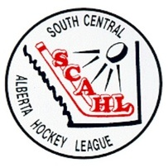
The SCAHL season will consist of approximately 34 games, half of those will he home games.

TEAM SELECTION
All eligible players will be evaluated by professional, payed, impartial, outside evaluators during tryouts.
All players will be treated equally and fairly, regardless of what their home association is.
Players from outside the Sylvan Lake “AA” HOCKEY MODEL DRAW ZONE may be permitted to participate in second tryouts, if the West Central AA HUB committee deems the tryout numbers or talent level lower than acceptable.
There will be no regional player quotas assigned when choosing the team.
OPERATION
Although these teams will be operated and identified as a separate entity, reporting will be complete and regular back to each “AA” HOCKEY MODEL RECRUITMENT AREA committee and “AA” HOCKEY MODEL RECRUITMENT AREA association, registration will be completed through Sylvan Lake Minor Hockey, in association with the West Central Tigers AA Hub.

The Tigers are a run by The West Central Tigers AA Hub, in association with Sylvan Lake Minor Hockey.

The Tigers Representatives will work with the team coaching staff, team management and Sylvan Lake Minor Hockey Office Administration Staff to operate the Hockey Club smoothly and efficiently. The West Central Tigers AA HUB Committee Representatives will report back to their respective “AA” HOCKEY MODEL RECRUITMENT AREAS and host associations.

Anyone determined to be working against the progress and well being of the long term or day to day positive operation of the Panthers organization will be suspended, removed of responsibility or removed of involvement.

CONTACT

For more information on our program please contact:

The Sylvan Lake Minor Hockey Office
Box 9089 – Nexsource Centre, Sylvan Lake, Alberta, T4S 1S6
403-887-2159
www.sylvanlakeminorhockey.com

