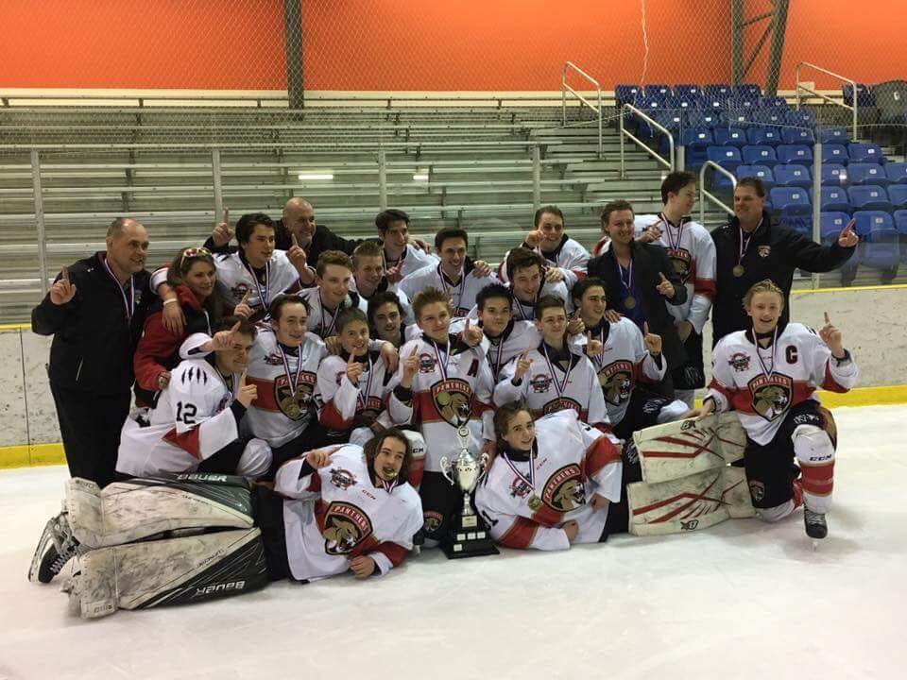

**HOCKEY CENTRAL PANTHERS**

**2017/2018 REMHL Regular Season and Playoff Champions**

**(inagural season)**

***SPONSORSHIP AND INFORMATION***

***PACKAGE***

**Our Vision:**

**“To provide 15-year old midget hockey players with age specific player development that prepares them for midget and junior hockey.”**

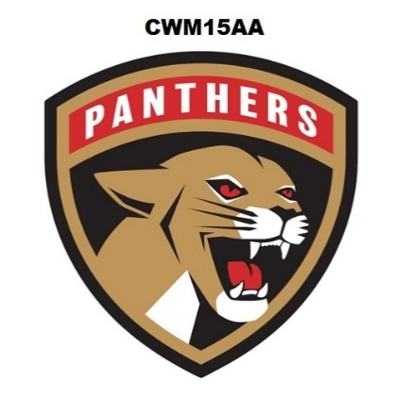

**TABLE OF CONTENTS**

About Us Pg. 3

Relationships and Regulation Pg. 4

Player Development Pg. 4

Coaching Pg. 5

Season and League Play Pg. 5.

Team Selection Pg. 6

Operation Pg. 7

Sponsorship Opportunities Pg. 8

Summary and Contact Information Pg. 10

**ABOUT US**

The Centre West Panthers organization is a second year Midget 15AA Hockey Club whose mission is to provide players with access to skilled coaching and programming that focuses on 15-year old midget hockey development in a challenging and fun environment.

Everyone in the organization will adhere to the notion of player development first - winning second.

Our vision to provide 15-year old midget hockey players with age specific player development that prepares them for midget and junior hockey.

Goals of the program:

* Provide access to highly-trained and skilled coaching;
* Make the hockey experience a fun and positive learning experience;
* Enhance the hockey skills of midget 15-year old hockey players;
* Provide an opportunity to play in a league that challenge players at their competitive skill and maturity level;
* Teach players skills that go beyond hockey and ensure lifelong learning and success.

Each coach, player and parent who participates in the Panthers program is expected to adhere to our organizations goals and standards:

Coaches, Parents and Players will be expected to work together to ensure a successful year.

Players are expected to represent themselves and the Panthers Organization with a high level of respect for themselves, team mates, opponents,

coaches, officials and

parents.

Players will

demonstrate the

willingness to make

sacrifices for the team.

Players will train in a

culture of excellence

and demonstrate their commitment to achieving their full potential on and off the ice.

**RELATIONSHIPS AND REGULATION**

The Panthers program is proud to be part of Rural Central Alberta’s historical hockey organizations. The Panthers are the result of a collaboration between Lacombe Minor Hockey, Olds Minor Hockey and Sylvan Lake Minor Hockey.

Only 15-year old hockey players in their 1st year of midget eligibility, residing within the “AA” HOCKEY MODEL RECRUITMENT AREAS of Lacombe (Central Alberta Selects), Olds (Olds Grizzleys) and Sylvan Lake (West Central Tigers) are eligible to tryout (this does not include players inside the boundaries of Red Deer Minor Hockey).

Although eligible, players within the Lacombe, Olds and Sylvan Lake “AA” Hockey Model Recruitment Areas will not be allowed to tryout without permission to tryout from their home associations and if advancement occurs, permission to play for the Panthers, without gaining a proper permission from their home association.

The Midget 15AA Panthers will not interfere with eligible associations to release their players, we are simply offering a development opportunity that we feel will benefit the entire area.



Home games and practices will be at or near Sylvan Lake. There will be an effort to centralize the team games and practices this year, however there may be some games at or near Olds and Lacombe depending on ice availability.

**PLAYER DEVELOPMENT**

Our player development model revolves around three key areas, accentuated by the focussed goals, maturity and skill level of 15-year old athletes:

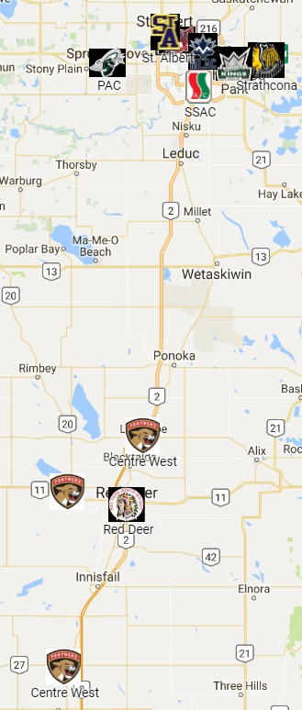1. Skating - Players will be taught how to understand their edges, how to control their core, how to generate and maintain speed, while building stamina and then integrating these skills with a puck.

2. Individual Skill - Players will be given the opportunity to work on their shooting, passing and stick handling at game speed. There will be an emphasis on developing creativity around these skills.

3. Team Play - Players will work on offensive and defensive tactics, systems and strategies. They will learn these skills in game-like drills and situations.

4. Fun - The game of hockey was meant to be fun and challenging. An emphasis will be placed on making practices and games positive and fun for all players.

**COACHING**

There will be an emphasis placed on coach development within our organization. There is a strong understanding that our player development is tied directly to our coaches and their level of expertise and pedagogy. As the Panthers are a regional team, it is the goal of the organization to provide players with a diverse well-rounded coaching staff from across all regions of the Central Alberta recruitment area.

**SEASON AND LEAGUE PLAY**

The REMHL season will consist of approximately 32 games, half of those will he home games. There are 11 teams scheduled to complete during the 2017/2018 season.

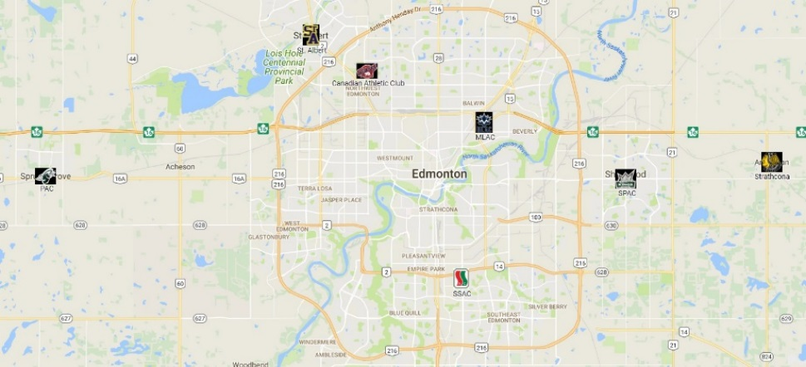<https://www.google.com/maps/d/viewer?mid=15QxrDxIUDhxhP7q9ozgIC0UcHtY&usp=sharing>

There is the potential for a pre-season tournament, prior to final cuts. There are other potential tournaments during the season, however this will be determined by the program administrators and coaching staff. Note: Whitecourt is currently being considered as a partner as early as next season.

All teams make the playoffs; league playoffs will consist of a first round 3 game best of series, the following rounds (as required) will consist of 5 game best of series.

**TEAM SELECTION**

All eligible players will be evaluated by professional, payed, impartial, outside evaluators during tryouts.

All players will be treated equally and fairly, regardless of what their home association is.

No players from outside the Lacome, Olds and Sylvan Lake “AA” HOCKEY MODEL RECRUITMENT AREAS will be permitted to participate in tryouts, first or secondary included.

There will be no regional player quotas assigned when choosing the team.

**OPERATION**

Although this team will be operated and identified as a separate entity, reporting will be complete and regular back to each “AA” HOCKEY MODEL RECRUITMENT AREA committee and “AA” HOCKEY MODEL RECRUITMENT AREA association, registration will be completed through Sylvan Lake Minor Hockey, in association with the West Central Tigers AA Hub.

The Panthers are a run by The West Central Tigers AA Hub, in association with Sylvan Lake Minor Hockey, Lacombe Minor Hockey, Lacombe Minor Hockey, The Central Alberta Selects AA Hub and Olds Minor Hockey AA Hub

The M15 Representatives will work with the team coaching staff, team management and Sylvan Lake Minor Hockey Office Administration Staff to operate the Hockey Club smoothly and efficiently. The M15 Representatives will report back to their respective “AA” HOCKEY MODEL RECRUITMENT AREAS and host associations.

Anyone determined to be working against the progress and well being of the long term or day to day positive operation of the Panthers organization will be suspended, removed of responsibility or removed of involvement.

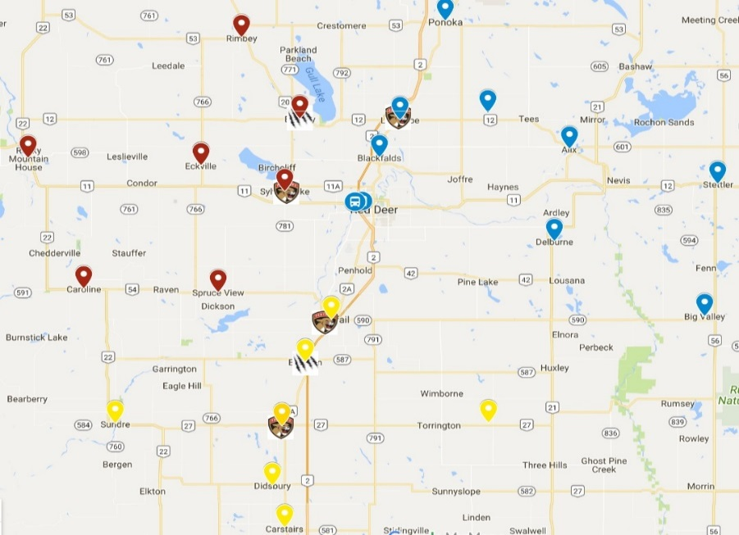

<https://www.google.com/maps/d/u/0/edit?hl=en&authuser=0&mid=1h-al2sBcc0Uoa0_W-2nRAwLm8gE&ll=52.311474537453314%2C-114.55617339843747&z=8>



**2017-2019 PLATINUM SPONSOR**

***“EMBRACE THE OPPORTUNITY”***

***GET INVOLVED AS A SPONSORSHIP PARTNER***

***Utilize the Centre West Panthers and its Strategic Marketing Opportunities to Support Midget 15-Year Old Hockey in the Central Alberta region and to Raise your Corporate Profile.***

**SPONSORSHIP OPPORTUNITIES**

Corporate groups can “*embrace the opportunity”* to support minor hockey in the Central Alberta area while at the same time promote their brand via the Panthers.

The Panthers organization is kindly requesting support from the local business community.

Thank you in advance for considering the following corporate partnership opportunities and know that we greatly appreciate your support regardless of any commitment.

Your sponsorship will be recognized from all across the Edmonton region and throughout Central Alberta.

|  |  |
| --- | --- |
| ~~PLATINUM (NAMING SPONSOR)~~ | ~~$5,000.00~~ |
| GOLD (EVENT SPONSOR) | $2,000 |
| SILVER (PRACTICE JERSEY SPONSOR) | $500-$1,000 |
| SILENT AUCTION | ANY DONATION |

**~~“PLATINUM” SPONSORSHIP BENEFITS~~**

**~~(NAMING SPONSOR)~~**

~~Our Platinum sponsorship level is for one sponsorship of $5,000. This is the criteria for club sponsorship.~~

* ~~Your team name would become a part of the official team name…~~***~~COMPANY NAME Panthers~~***
* ~~Your team logo would be proudly displayed our Panthers Jersey.~~
* ~~Your logo proudly displayed on our Panthers website, social media, game programs and promotional materials;~~
* ~~A Panthers team photo with your company name on it to display at your place of business;~~
* ~~Your logo will receive local media recognition;~~

**“GOLD” SPONSOR BENEFITS**

**(EVENT SPONSOR)**

Our Gold sponsorship level is for a sponsorship of $2,000. This is the criteria for club level sponsorship.

* Your logo proudly displayed on our Panthers website, social media, game programs and promotional materials;
* A Panthers photo with your company name on it to display at your place of business;
* Your logo will receive local media recognition.
* Your logo will be prominent during all team special events, such as awards banquets, fundraising events, etc. Each special event will be named after your company.

**“SILVER” SPONSOR BENEFITS (PRACTICE JERSEY SPONSOR)**

Our Silver sponsorship level is for a sponsorship of $500-$1000. This is the criteria for team sponsorship. Benefits for this sponsorship would include:

* Your logo proudly displayed on our Panthers practice jerseys, website, social media, game programs and promotional materials;
* A Panthers photo with your company name on it to display at your place of business;

**“SILENT AUCTION” SPONSOR BENEFITS**

An important part of our fundraising initiatives includes our Silent Auction's. All donations will be acknowledged at the event and the donating company or individual name will be displayed on the auction table. We will also recognize your company via the Panthers website.

**SUMMARY**

Thank for taking the time to consider corporate sponsorship opportunities that exist via the Panthers Hockey Club. Your generous support will ensure a successful inaugural year for the Panthers players.

For more information on our program or to secure your corporate sponsorship please contact:

**The Sylvan Lake Minor Hockey Office**

Box 9089 – Nexsource Centre, Sylvan Lake, Alberta, T4S 1S6

403-887-2159

**Blair Mack**

Past President – Sylvan Lake Minor Hockey

M15AA Governor – West Central AA Model Hub

CWM15 Panthers Rep.

P: (403) 506-1771

E: [pastpresident@slmha.hockey](mailto:pastpresident@slmha.hockey)

facebook

**@M15AAPanthers**